SITE NOTICES PLACED AT AGGENEYS TOWN

a.  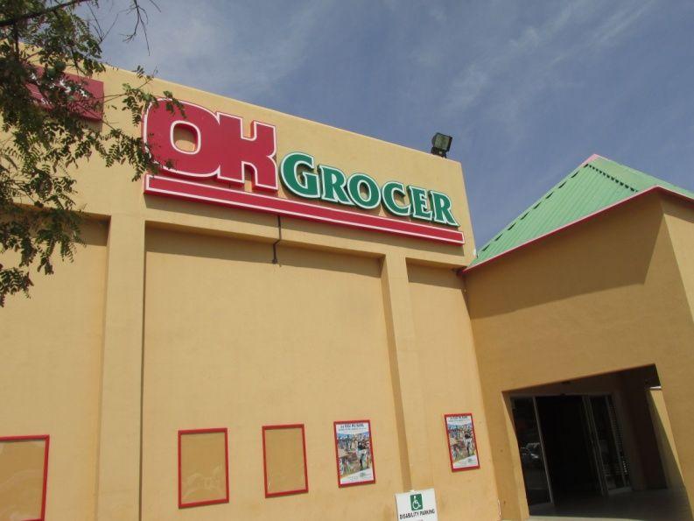 | b.  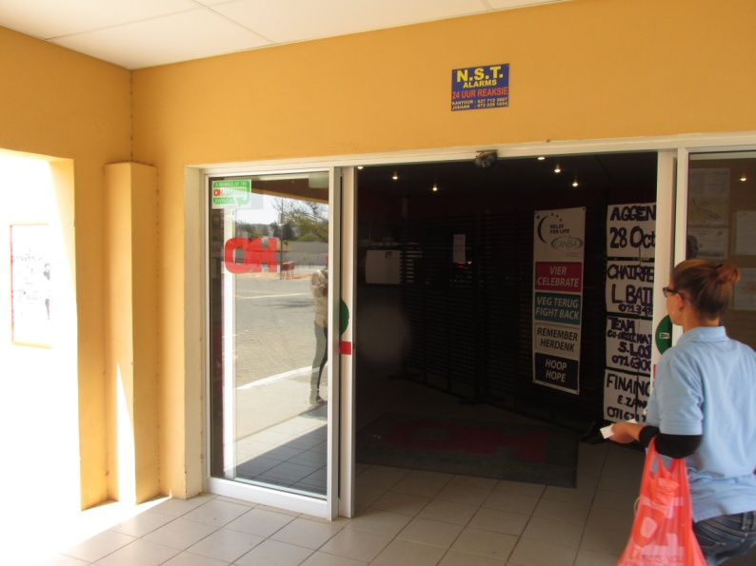
c.  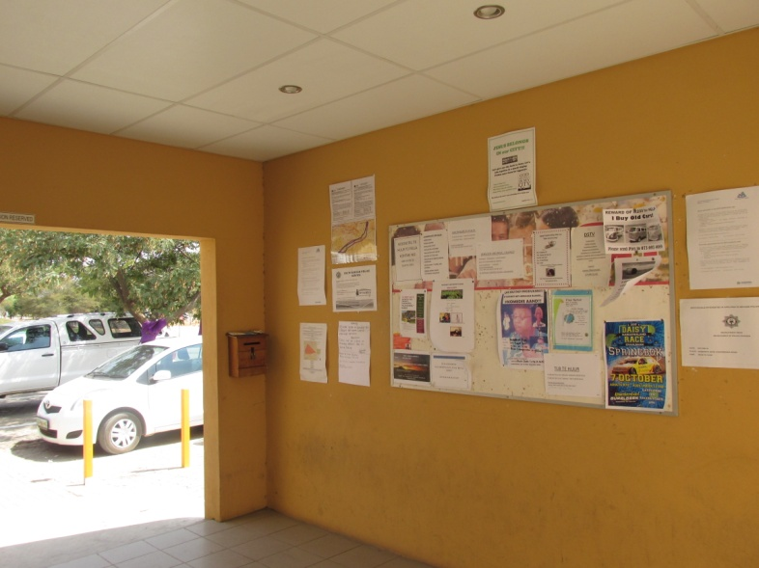 | d.  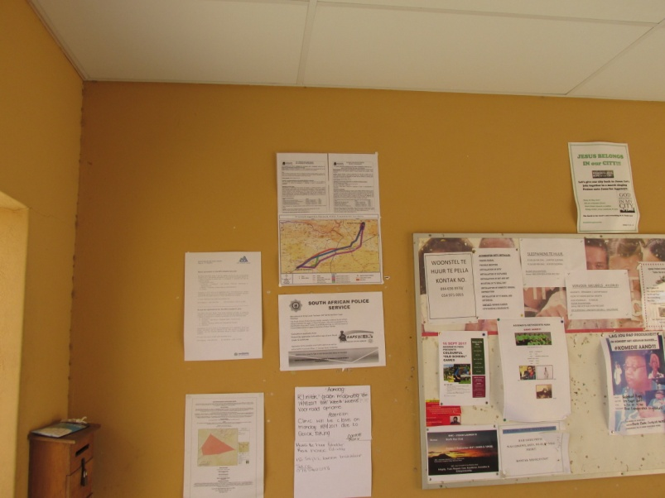
Photograph 1: The site notice was placed at OK Store. The site notice is indicated in the red circle in 1d (bottom right).

a.  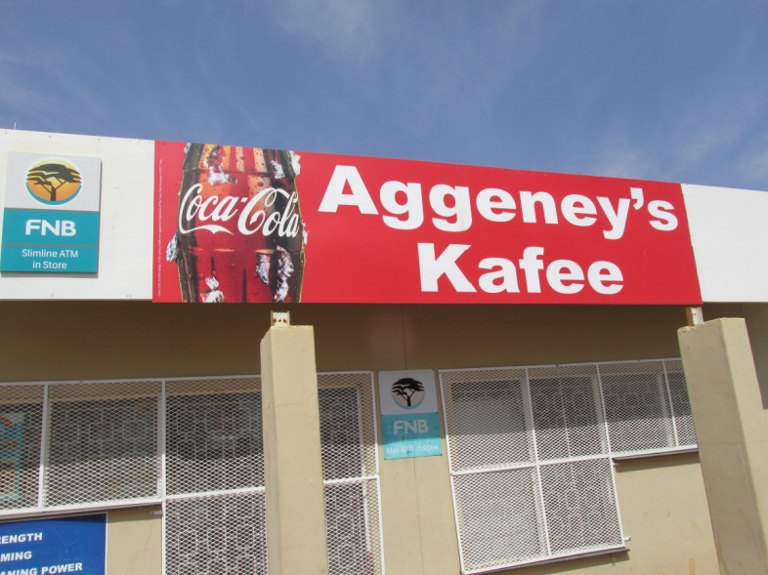 | b.  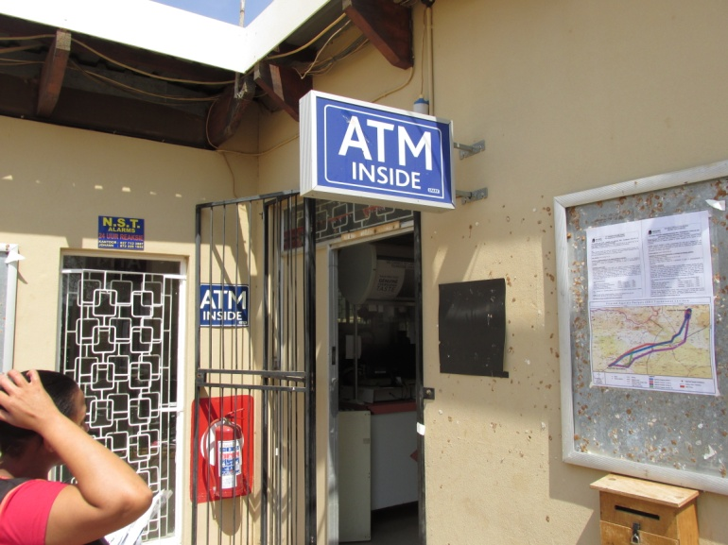
c.
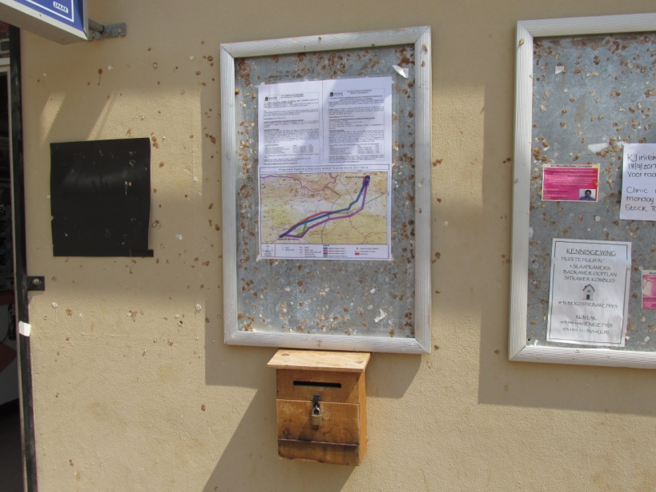

Photograph 2: The site notice was placed at Aggeneys Kafee

a.
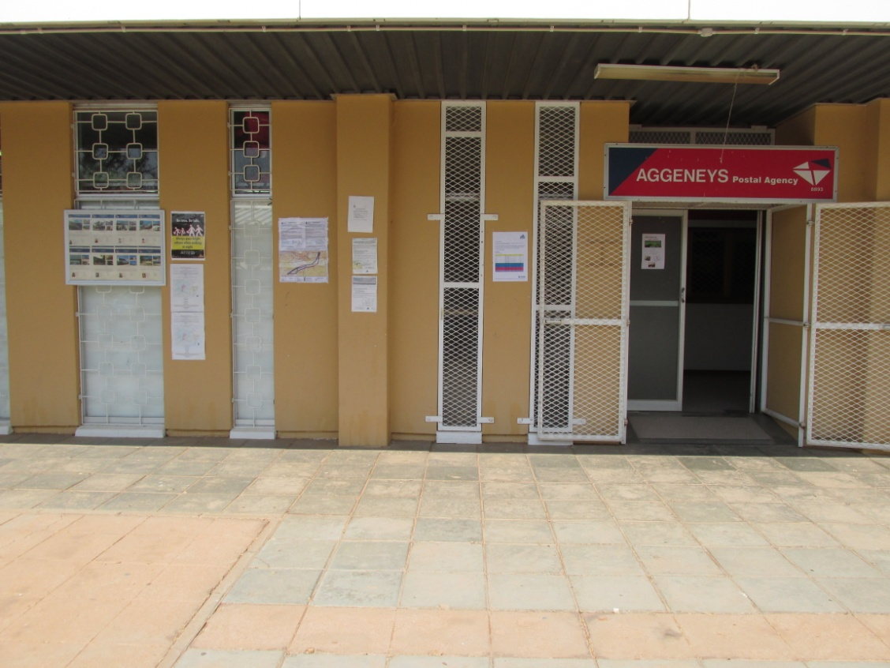

b.
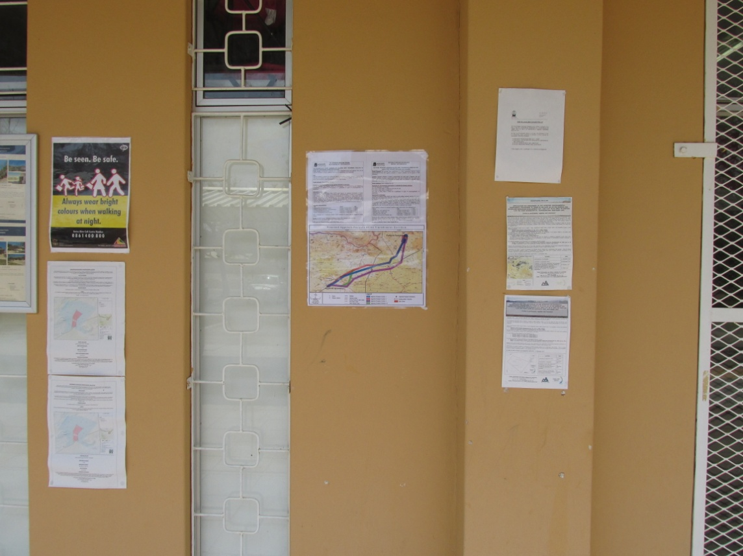

Photograph 3: The site notice was placed at Aggeneys Post Office

a.
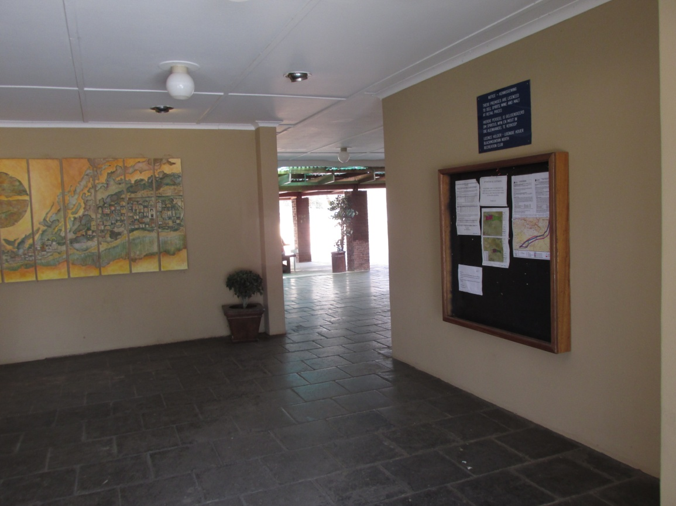

b.
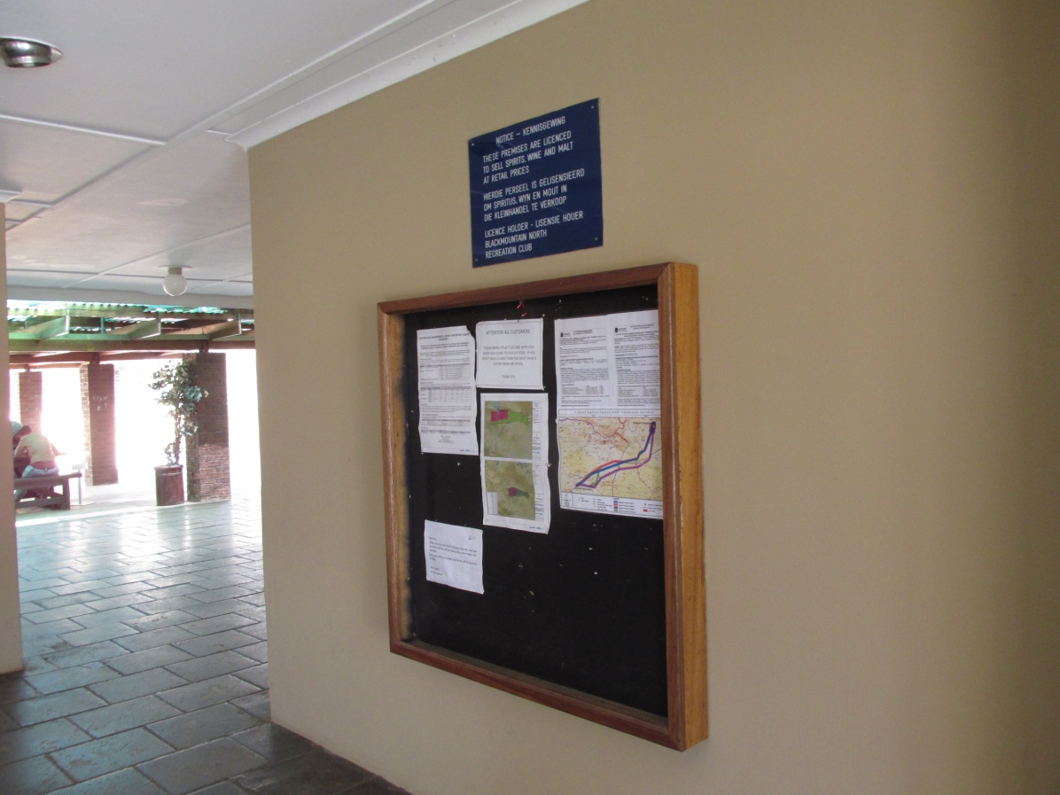

Photograph 4: The site notice was placed at Aggeneys Recreational Club

SITE NOTICES PLACED AT PELLA TOWN

a.  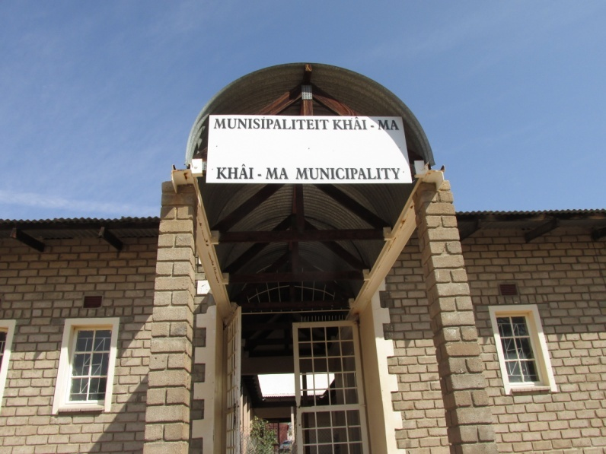 | b.  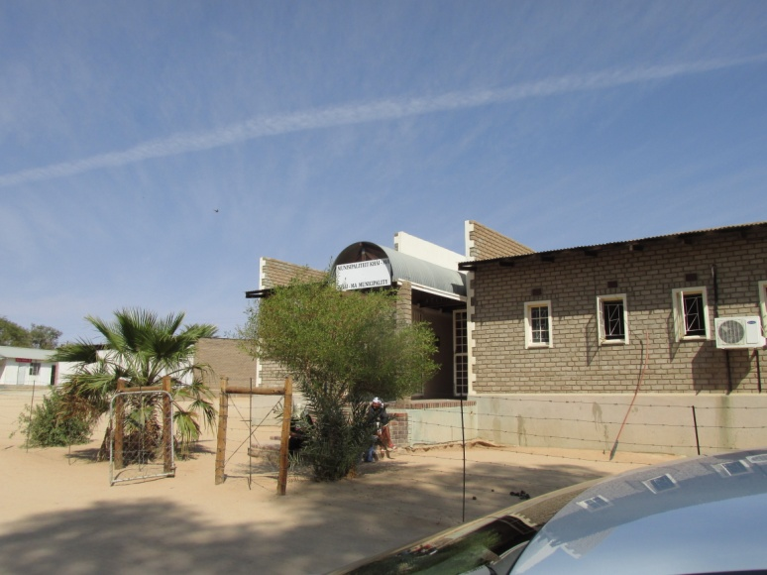
c.
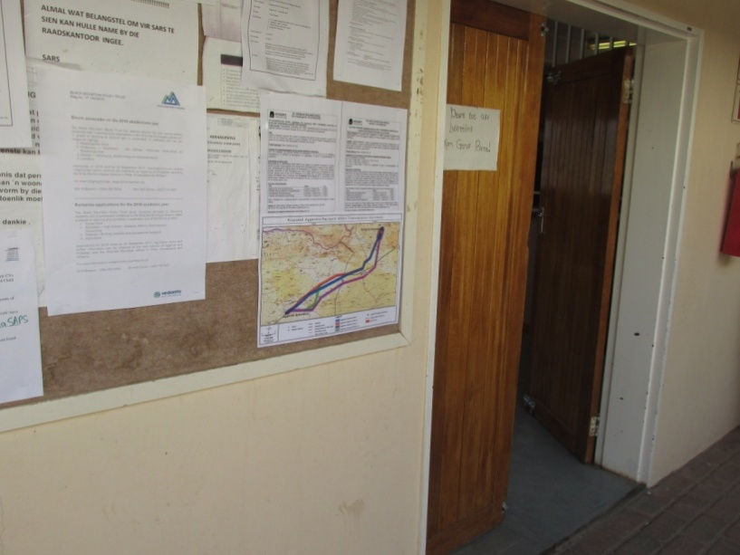

Photograph 5: The site notice was placed at the Local Municipality in Pella

a.
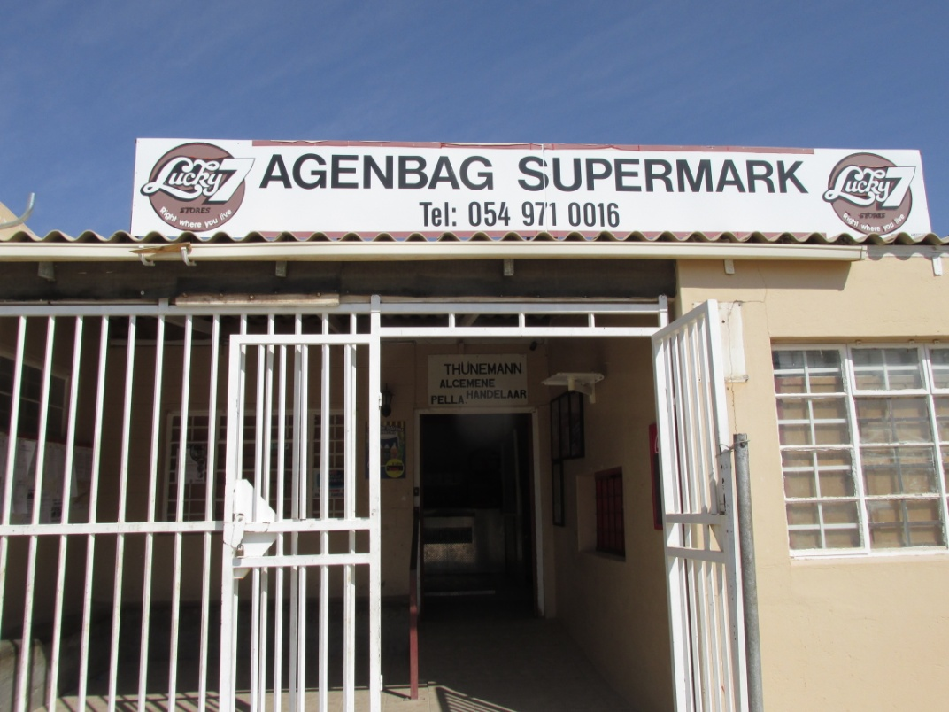

b.
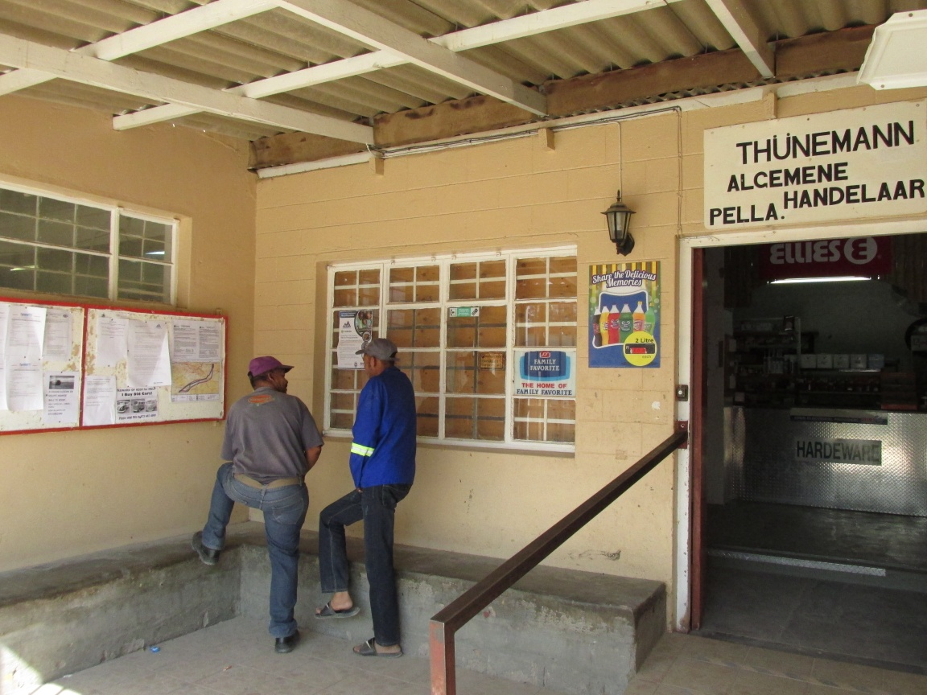

Photograph 6: The site notice was placed at Agenbag Supermarket in Pella

a.
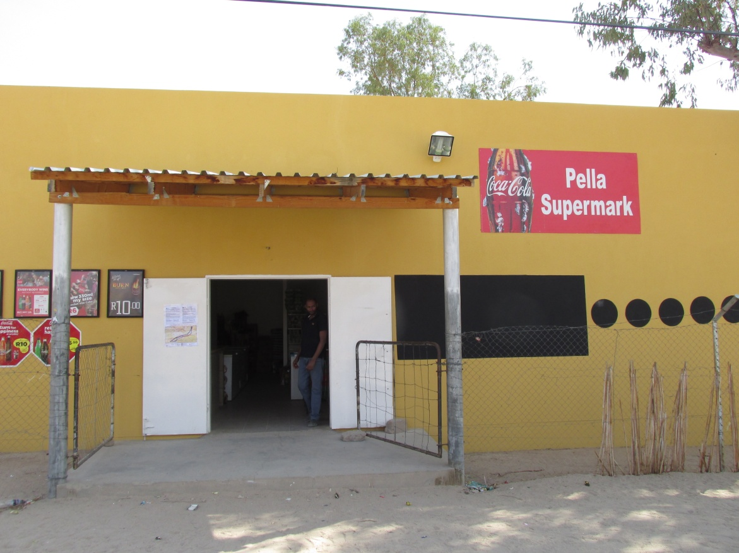

b.
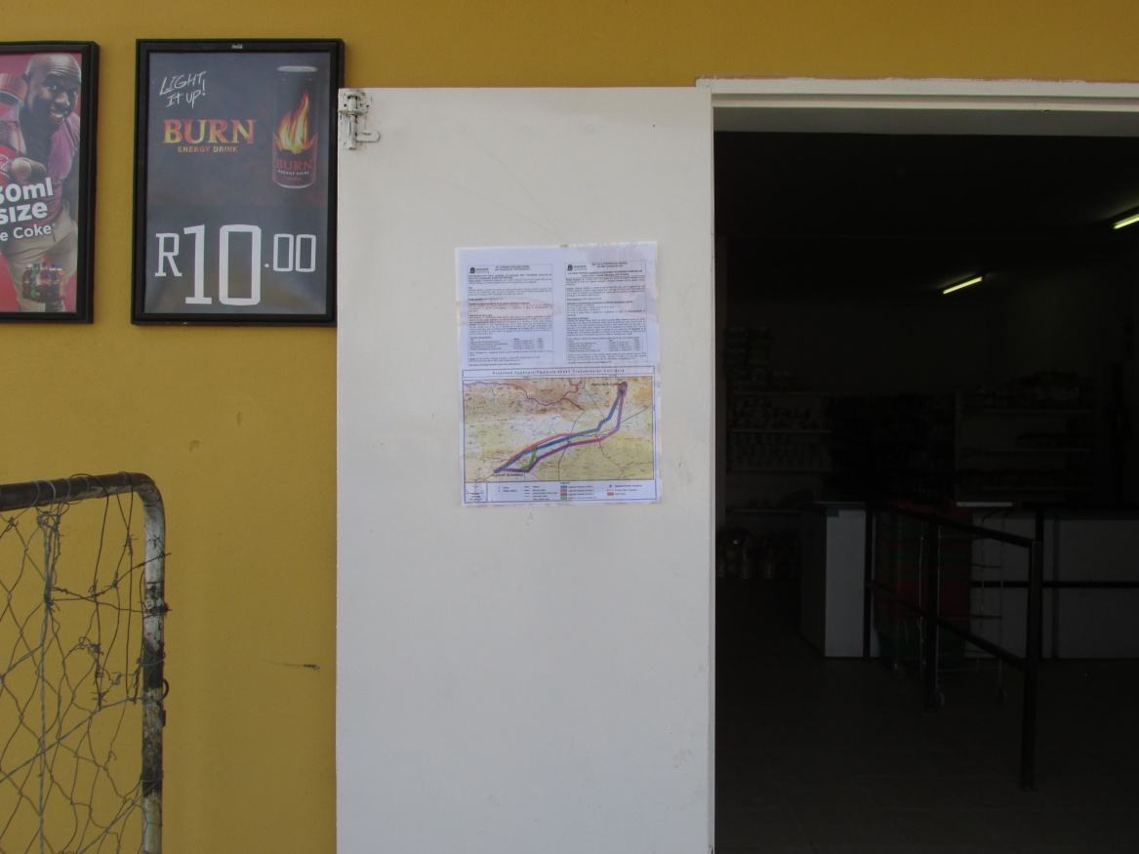

Photograph 7: The site notice was placed at Pella Supermarket

SITE NOTICES PLACED AT POFADDER TOWN

a.
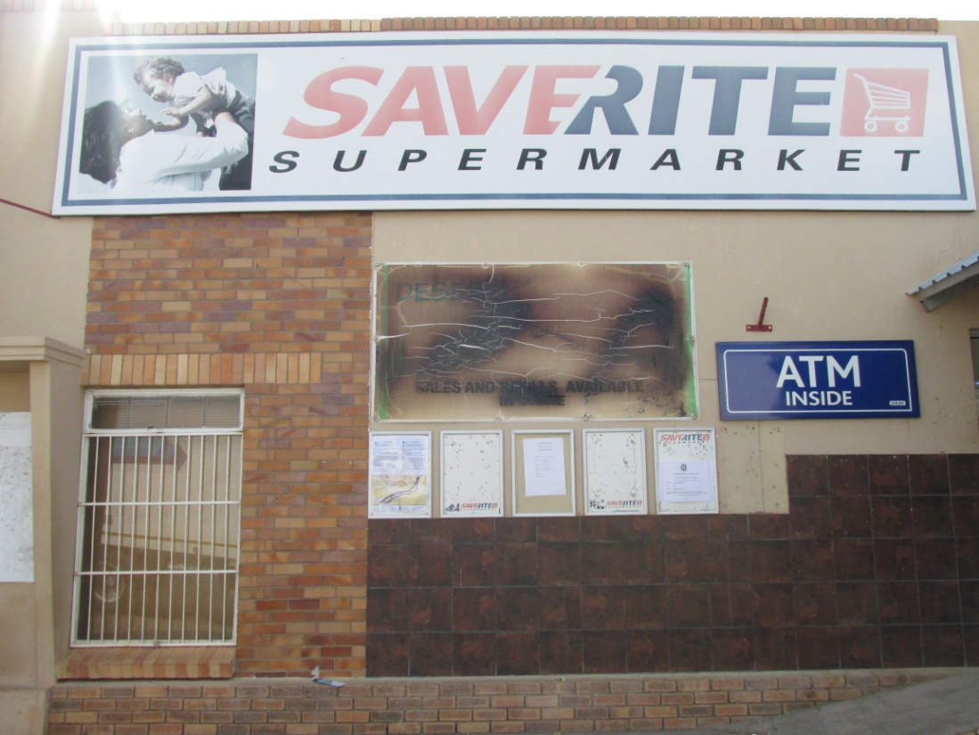

b.
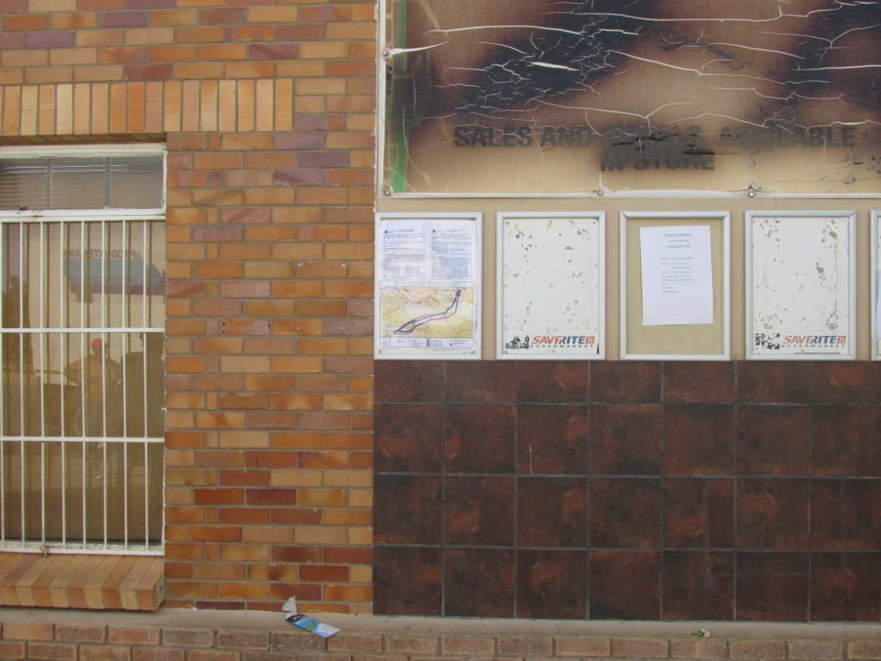

Photograph 8: The site notice was placed at Pofadder Saverite Supermarket

a.
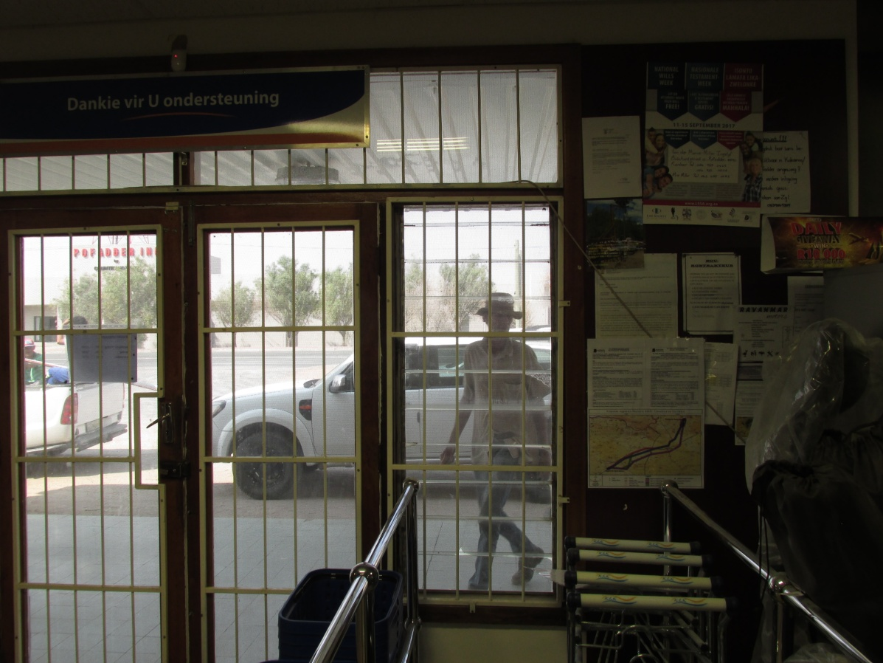

b.
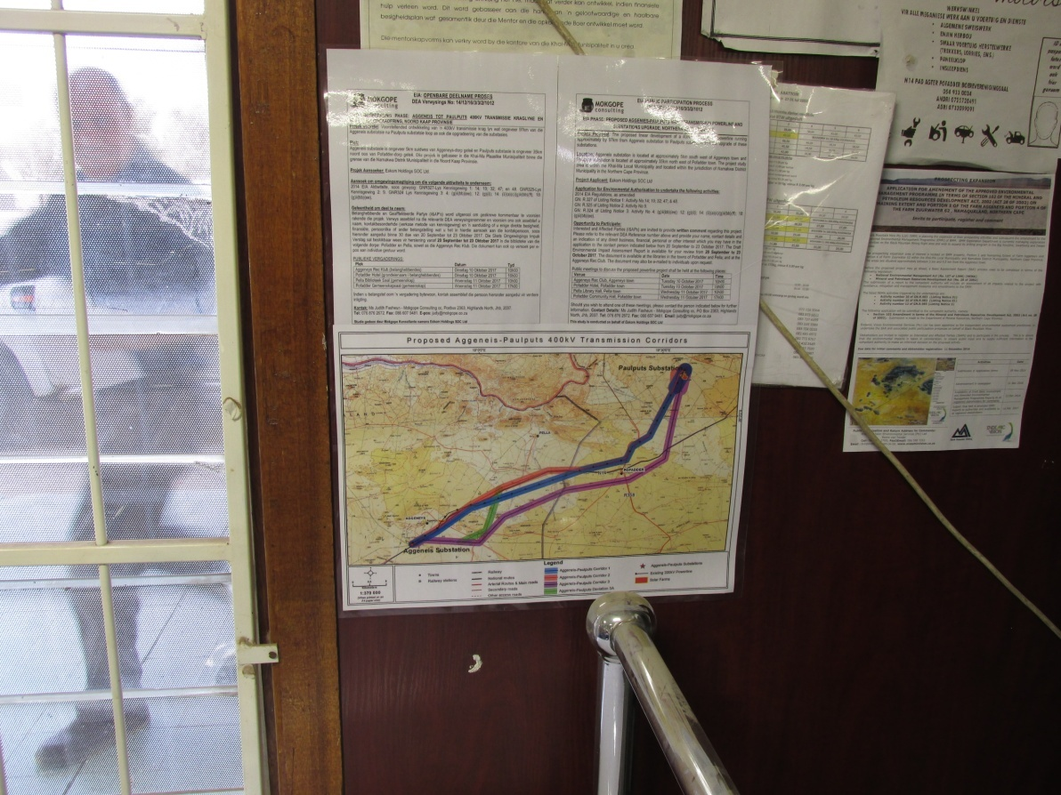

Photograph 9: The site notice was placed at Pofadder GWK

a.
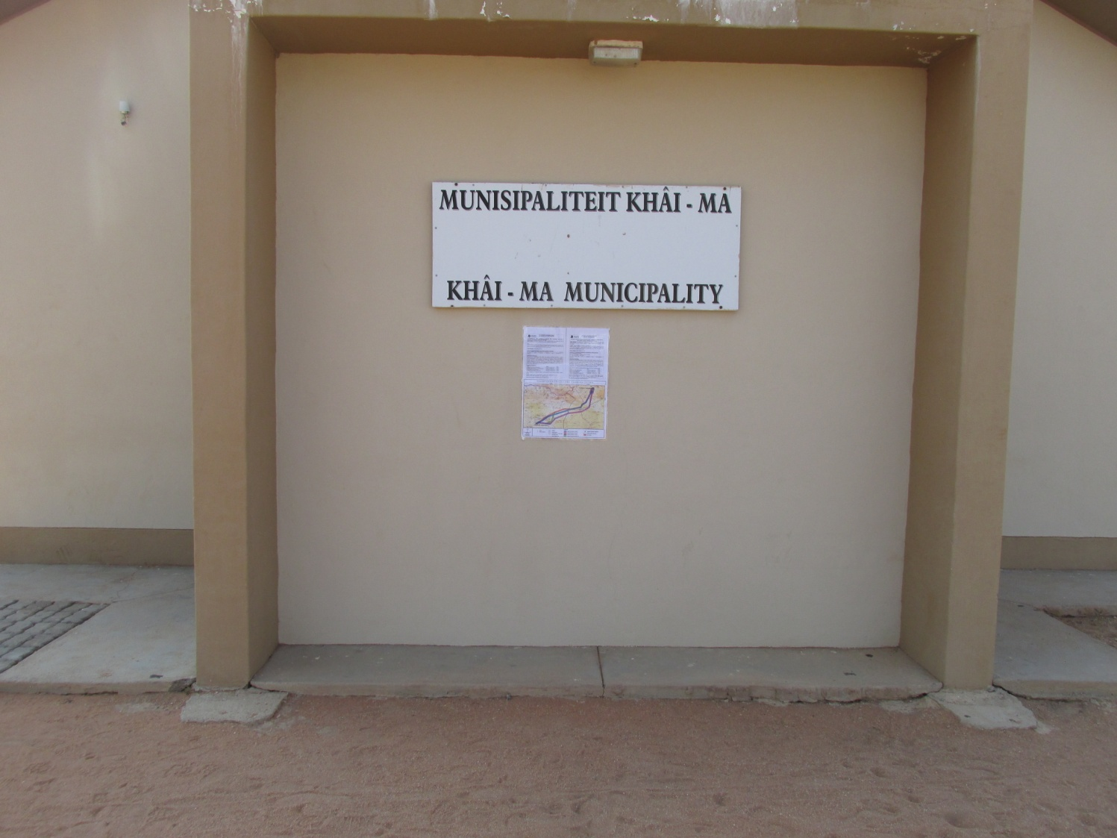

Photograph 10: The site notice was placed at the Local Municipality in Pofadder

a.
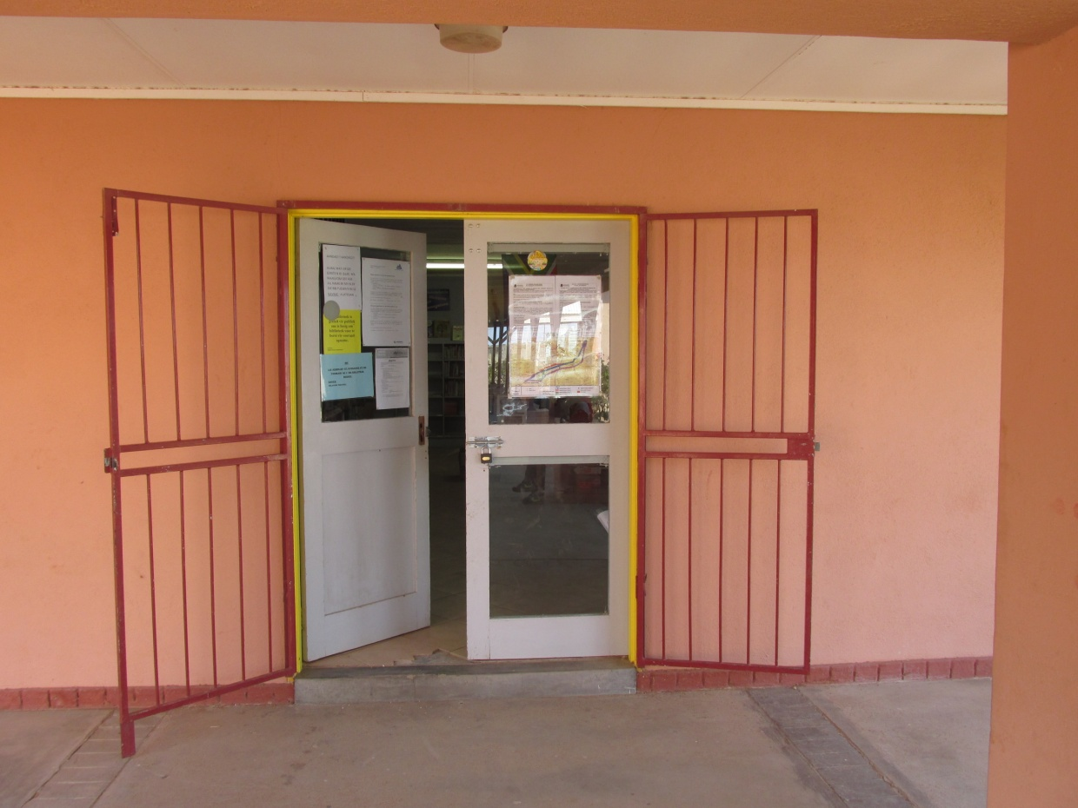

b.
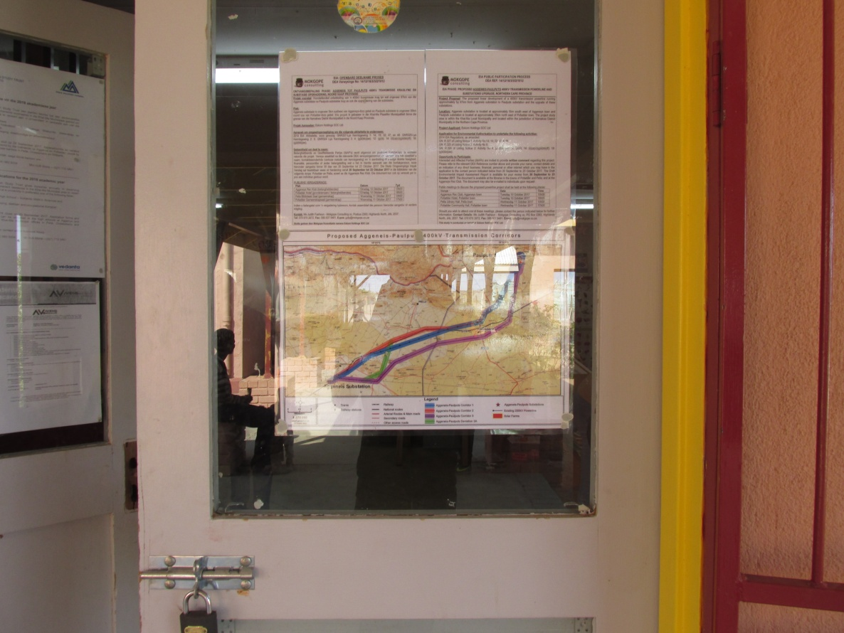

Photograph 11: The site notice was placed at Pofadder Library

